**THE PRICE OF POVERTY**

Malaria and national poverty are inextricably linked, with the burden of the disease falling entirely upon the developing world. Efforts by the WHO through the Global Fund and other national / multilateral donors have had a substantial impact in reducing the incidence of the disease over the past decade. However, the link between poverty and the disease remains, with the burden still following on the poorest of the poor countries.

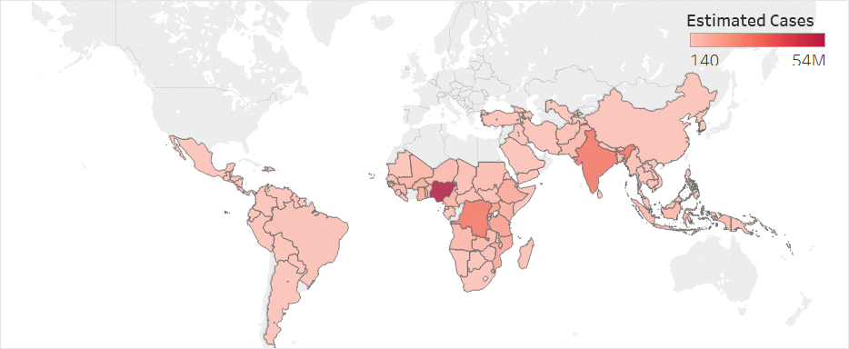**Malaria and National Poverty**

**Cases of Malaria - 2000**

**Figure 1:** Cases of malaria in 2000. Note the absence of the richest nations, including Western Europe, Australia, Canada, and the United States, which had eradicated malaria decades earlier. Source: WHO

The story of malaria is a story of poverty. While malaria [took the lives of more than 800,000 people](http://www.who.int/gho/malaria/epidemic/deaths/en/) at the start of the new millennium, no cases let alone deaths occurred in Western Europe, Australia, Canada, or the United States. The link to poverty went even deeper than just the contrast between developed and developing countries however, as in 2000 malaria was almost entirely concentrated in the poorest of countries.

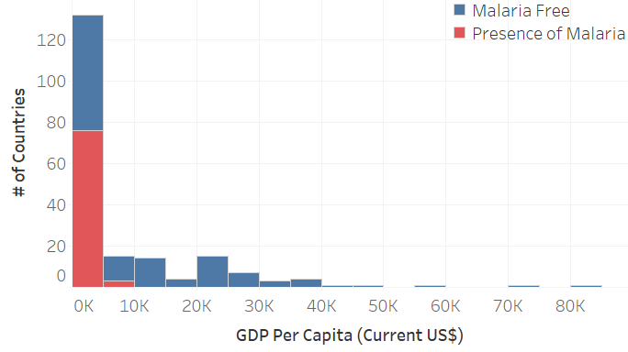Although no vaccine exists, countries like the United States rid themselves of the disease through programs that attacked the source of the disease, mosquitoes, either directly in the form of pesticides or indirectly through the destruction of mosquito breeding grounds. While it had seemed reasonable to assume that developing nations would then adopt the same malaria eradication practices as the developed nations, *decades* had passed and still hundreds of thousands of people were perishing from the disease. Whether it was a lack of political will or [crushing cycles of poverty partially driven by the disease itself](https://www.ncbi.nlm.nih.gov/pubmed/18579874), it was clear that these countries did not and likely never would have the resources to fight this disease.

**Malaria and GDP per Capita - 2000**

**Figure 2:** In 2000, malaria was concentrated in the poorest countries in the world, as more than 50% of all countries with less than $5,000 GDP per Capita have cases of the disease. Sources: WHO, World Bank

**Funding to Close the Gap**

In response to the epidemics of malaria as well as tuberculosis and AIDS and the resource gap that existed to combat them in the poorest countries, the WHO led the creation of the Global Fund in 2002. While domestic funding for malaria control and elimination programs remained relatively consistent for the next decade, the Global Fund and other national and multinational donors would significantly ramp up their funding efforts and provide most of the funds going to these programs, particularly starting in 2009 when overall funding increased by 45%.

**Funding for Malaria Programs**

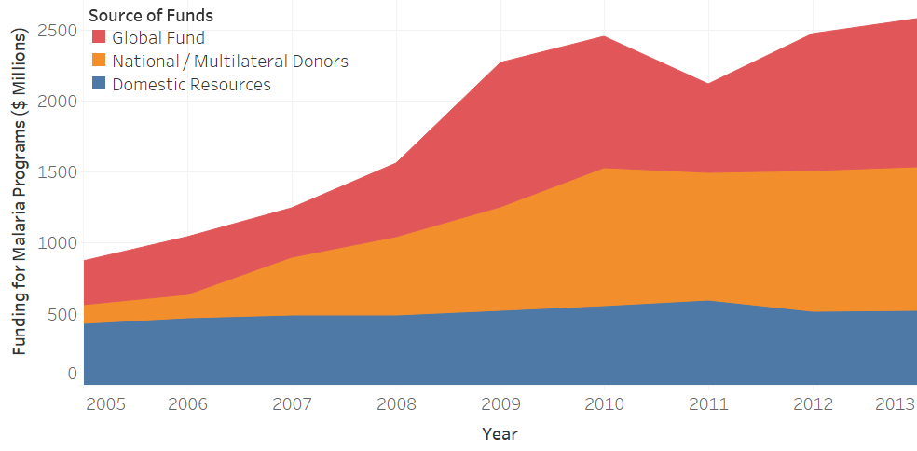

**Figure 3:** Over the previous decade, the WHO-led Global Fund and Multinational Donors have substantially increased their support for malaria control and elimination while domestic funding from countries with malaria remained flat. Source: WHO

**The Link Remains**

**Malaria Control and GDP per Capita**

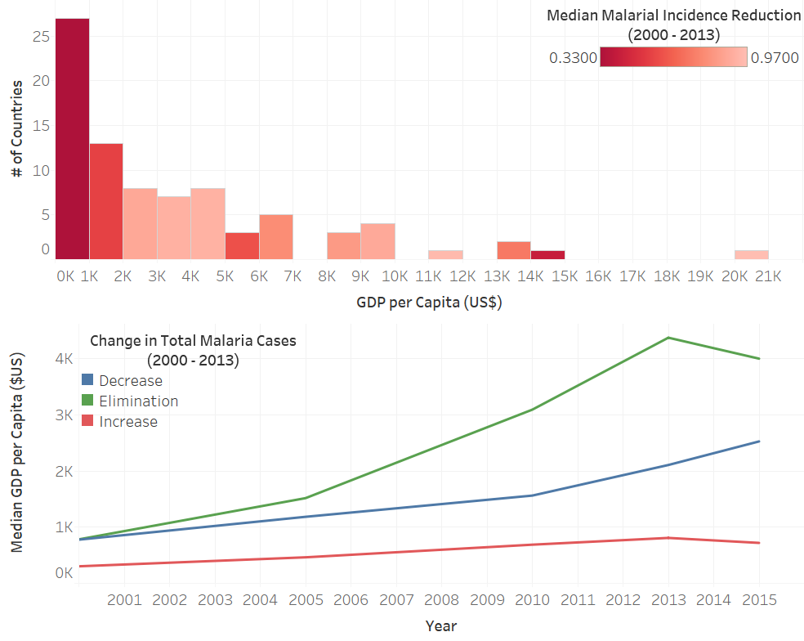Due in part to the WHO’s, the Global Fund’s and other donors’ efforts, by 2013 the incidence (% of people in a country with malaria) of malaria decreased for almost every country between 2000 and 2013. Nevertheless, the reductions in incidence are the lowest for the poorest countries, and, more strikingly, when examining the gross change in malaria cases, a clear dichotomy based on wealth emerges. So, while the efforts of the WHO have undoubtedly helped to reduce the burden of malaria around the world, the link between the disease and national poverty remains.

**Figure 4:** The top chart illustrates countries with the lowest malarial incidence reduction were also the poorest. The bottom chart shows an increasing wealth gap between countries that decreased or eliminated Malaria cases entirely and those that didn’t. Sources: WHO, World Bank